How to import a DLL and its XML documentation in a Visual Studio 2008 C# project:

- To use the DLL in your Visual Studio project, copy both HapticDriver.DLL and HapticDriver.XML files to the project directory. The XML file contains the reference documentation for all publically accessible methods, variables, etc.

- In Visual Studio 2008, right-click on your project’s References -> Add Reference:

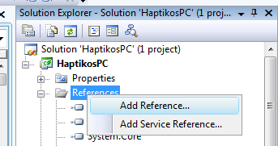

- Click on the Browse tab and select the DLL file you just created.

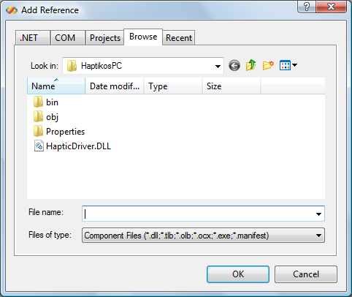

You do not need to do this step for the DLL’s associated XML file as long as they have the same name and reside in the same directory.

- You can now include references to this DLL by normal methods:

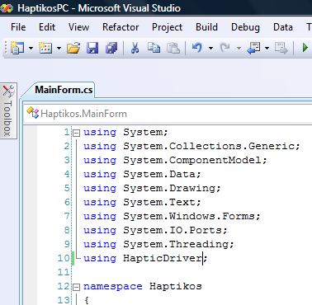

For more resources on C# Compiler Options see the webpages:
http://msdn.microsoft.com/en-us/library/78f4aasd.aspx

OR

http://msdn.microsoft.com/en-us/library/6s2x2bzy.aspx

How to use the HapticDriver DLL for the Wireless Haptic Belt:

The DLL driver for the Wireless Haptic Belt is well documented using Microsoft’s Visual Studio IntelliSense® XML comments that appear as you are using one of the driver’s publically accessible methods or functions (see below).

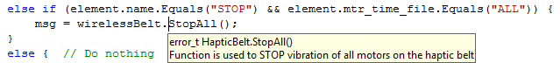

While the methods are well documented in parameters and returned data types, they do not give much detail on the required steps to connect and use the Wireless Haptic Belt through a Windows OS Bluetooth connection. Below are the steps that must take place in order to activate and control the belt:

- Instantiate the HapticDriver as an object.
- Setup your PC’s Bluetooth port configured for Serial Port Protocol (SPP) using the HapticDriver’s SetupPorts( ) utility.
- Connect to the Bluetooth port using the HapticDriver’s OpenPorts( ) utility.
- Verify a successful connection by checking the returned data with the HapticDriver’s error_t.ESUCCESS enumeration.
- Activate one of the vibration patterns/motors that is programmed in the Haptic Belt’s memory using the HapticDriver’s Vibrate_Motor( ) utility.
- Disconnect from the Bluetooth port when you are finished utilizing the Wireless Haptic Belt. This is completed by using the HapticDriver’s ClosePorts() utility.

***Although not required for activating the Wireless Haptic Belt, it is highly recommended to utilize the HapticDriver’s Query functions to determine what vibration patterns, magnitude settings and the number of motors attached. Some error handling is also built into the Query functions.

Instantiating the HapticDriver:

This step is identical to almost all other instantiations; for easier identification the object class in the driver is named HapticBelt. The HapticBelt object provides a utility that allows you to execute a particular method in you program when data is received from the Wireless Haptic Belt into the driver’s object. This works much like a C++ function pointer.

code snippet from HaptikosPC MainForm.cs
HapticBelt wirelessBelt = new HapticBelt();

// Subscribe event handler to the function ReceiveData( )
// This works like a C++ function pointer
wirelessBelt.DataReceivedFxn = this.UpdateTxtLog;

Setup the HapticDriver Bluetooth Port:

Your PC’s Bluetooth port is configured for Serial Port Protocol (SPP) using the HapticDriver’s utility. Usually the SPP configuration uses the same COM port number, but is some circumstances it is specified as a different port.

- COM port as a string = “COM” + port number (no spaces). For example: “COM8”.
- Baud rate of 9600.
- Data bits = ”8”.
- Stop bits = “1”.
- Parity = “None”
- COM port read time should be reasonable for distance between Bluetooth modules. 1000 milliseconds is usually a good starting point. This parameter uses an integer.
private void mnuConnect_Click(object sender, EventArgs e) {

// Setting up serial ports
wirelessBelt.SetupPorts(inboundPort, outboundPort, baud_string, databits_string, stopbits_string, parity_string, readTimeout);

code snippet from HaptikosPC MainForm.cs

If your program has a user selection for the COM port, you can use the HapticDriver’s GetSerialPortNames() utility which returns an array of COM port names and accounts for some of the Windows OS issues of SerialPort.GetPortNames() which might return an invalid string such as “COM12c”. The array can be added to a ComboBox for selection.

string[] ports = belt.GetSerialPortNames();//SerialPort.GetPortNames();

// ComboBox 1 = inbound ports
comboBoxInbound.Items.Add("NO PORT SELECTED");
for (int i = 0; i < ports.Length; i++) {
comboBoxInbound.Items.Add(ports[i]);
}

// ComboBox 2 = outbound ports
comboBoxOutbound.Items.Add("NO PORT SELECTED");
for (int i = 0; i < ports.Length; i++) {
comboBoxOutbound.Items.Add(ports[i]);
}

// Selection of port names
if (comboBoxInbound.Items.Contains(inboundPort))
comboBoxInbound.SelectedItem = inboundPort;
else
comboBoxInbound.SelectedIndex = 0;

if (comboBoxOutbound.Items.Contains(outboundPort))
comboBoxOutbound.SelectedItem = outboundPort;
else
comboBoxOutbound.SelectedIndex = 0;

code snippet from HaptikosPC SettingsForm.cs

Connect to the Wireless Haptic Belt Bluetooth Link and Verify Successful Connection:

To make the Bluetooth connection active in the use the HapticDriver’s OpenPorts()utility. There are, however two ways to verify that the connection is active. The first way is to check if the error code is successful (perhaps the simplest way).
wirelessBelt.OpenPorts();

// Check for success
if (wirelessBelt.getStatus() != error_t.ESUCCESS)
labelStatusMsg.Text = wirelessBelt.getErrorMsg(wirelessBelt.getStatus());

The second is the check that the message in the data buffer is of MessageType.NORMAL which indirectly verifies that the connection process has been successful at the driver’s lowest level. If the Bluetooth SPP port on your computing device uses the same COM port number for inbound and outbound, it is important to not try and open a new connection on the outbound port. This results in unnecessary processing and may cause some latency issues.

wirelessBelt.OpenPorts();

// Check for success
if (wirelessBelt.getDataRecvType() == (byte)HapticDriver.MessageType.NORMAL)
labelStatusMsg.Text = "Input port opened.";
else if (wirelessBelt.getDataRecvType() == (byte)HapticDriver.MessageType.ERROR)
labelStatusMsg.Text = "Error: " + wirelessBelt.getStatusBuffer();

// Try Output port
if (inboundPort != outboundPort) {
// Check for success
if (wirelessBelt.getDataRecvType() == (byte)HapticDriver.MessageType.NORMAL)
labelStatusMsg.Text = "Output ports opened.";
else if (wirelessBelt.getDataRecvType() == (byte)HapticDriver.MessageType.ERROR)
labelStatusMsg.Text = "Error: " + wirelessBelt.getStatusBuffer();
}
code snippet from HaptikosPC MainForm.cs mnuConnect_Click( )

Activating Vibration Patterns and Motors (Tactors):

There are two important commands is activating the Wireless Haptic Belt “Vibrate_Motor” and “Stop”. The Haptic belt was designed to maintain the activation of a specified vibration pattern until a Stop command has been given. The vibration patterns must already be programmed onto the haptic belt using the HaptikosPC application or through the text menu using a Terminal Emulator.

private void btnActivate_Click(object sender, EventArgs e) {
try { // Send Vibrate Motor Command
error_t response =
wirelessBelt.Vibrate_Motor((byte)comboBoxMotor.SelectedIndex,
comboBoxRhy.SelectedItem.ToString(),
magnitude_table[comboBoxMag.SelectedIndex],
(byte)(comboBoxCycles.SelectedIndex + 1));

if (response != error_t.ESUCCESS)
labelStatusMsg.Text = wirelessBelt.getErrorMsg(response);
else
labelStatusMsg.Text = "Activating motor " +
comboBoxMotor.SelectedItem.ToString()+ ". ";
}
catch (Exception ex) {
MessageBox.Show(ex.Message);
}
}
code snippet from HaptikosPC MainForm.cs
Stop command can be issued for a specified motor.

private void btnStop_Click(object sender, EventArgs e) {
try {
error_t response = wirelessBelt.Stop((byte)comboBoxMotor.SelectedIndex);

labelStatusMsg.Text = "Stop motor " + comboBoxMotor.SelectedItem.ToString()
+ ". ";// +wirelessBelt.getCommStatusMsg(); //TODO
}
catch (Exception ex) {
MessageBox.Show(ex.Message);
}
}
code snippet from HaptikosPC MainForm.cs

OR the Stop command can be issued for all motors.

private void btnStopAll_Click(object sender, EventArgs e) {
try {
labelStatusMsg.Text = "Stoping All Motors.";

error_t response = wirelessBelt.StopAll();

if (response != error_t.ESUCCESS)
labelStatusMsg.Text += " " + wirelessBelt.getStatusBufferStr()
+ " " + wirelessBelt.getErrorMsg(response);
else
labelStatusMsg.Text += " " + wirelessBelt.getStatusBufferStr();
}
catch (Exception ex) {
labelStatusMsg.Text = wirelessBelt.getStatusBufferStr()
+ " " + ex.Message;
}
}
code snippet from HaptikosPC MainForm.cs

Disconnecting from the Wireless Haptic Belt Bluetooth Link:

When you are done using the Bluetooth link to the Wireless Haptic Belt, it is important that you reset the HapticDriver’s state and close the ports so that .NET does not hold the Serial Port connection (may prevent future use).
error_t response = wirelessBelt.ResetHapticBelt();

if (response != error_t.ESUCCESS)
MessageBox.Show(wirelessBelt.getErrorMsg(response));

wirelessBelt.ClosePorts();

Using the HapticDriver belt Query Functions:

Although not required for activating the Wireless Haptic Belt, it is highly recommended to utilize the HapticDriver’s Query functions to determine what vibration patterns, magnitude settings and the number of motors attached. Some error handling is also built into the Query functions. Below is an example of how to use one of the HapticDriver’s Query functions.

private void btnQuery_Click(object sender, EventArgs e) {

try {
error_t response = wirelessBelt.Query_All();

if (response != error_t.ESUCCESS)
labelStatusMsg.Text = wirelessBelt.getErrorMsg(response);
else {
// brackets reqd for casting int array to string array
String[] motor = {wirelessBelt.getMotors(QueryType.PREVIOUS).ToString()};
String[] rhythm = wirelessBelt.getRhythm(false, QueryType.PREVIOUS);
String[] magnitude = wirelessBelt.getMagnitude(false, QueryType.PREVIOUS);

// Reset Combo Boxes
ResetAllComboBoxes();

AddToComboBox(dataTypes.MTR, motor, comboBoxMotor);
AddToComboBox(dataTypes.RHY, rhythm, comboBoxRhy);
AddToComboBox(dataTypes.MAG, magnitude, comboBoxMag);

// sets default to first index
comboBoxCycles.SelectedIndex = 0;

// Update status message
labelStatusMsg.Text = wirelessBelt.getStatusBufferStr() + ". ";
}
}
catch (Exception ex) {
labelStatusMsg.Text = wirelessBelt.getStatusBufferStr() + " " + ex.Message;
}
}
code snippet from HaptikosPC MainForm.cs

